ACCOUNTANT INSTRUCTIONS

This guide provides information needed for an accountant to manage transactions. Within this guide, you will learn how to:
- Allocate or edit a transaction
- Close a transaction
- Sweep a transaction
- Manage flags on a transaction
Each of the above topics includes step-by-step instructions for performing a specific task. You can review all of the tasks in this guide or review the task that is specific to your interest.

Allocate or Edit a Transaction
Procedure:
- On the Home Page under Action Items>Current Status, click on the Open link.
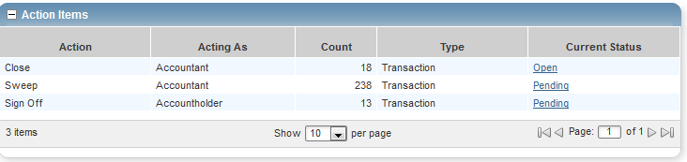
These are the transactions ready for accountant sign off.

- Click the desired Document number. A menu displays.
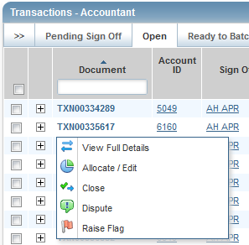

- Select View Full Details. The Transaction Detail screen displays.
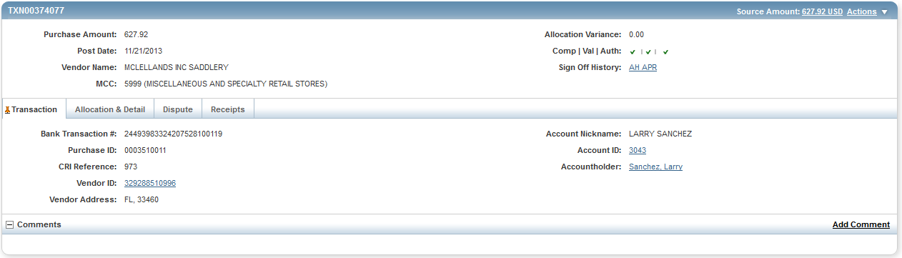

- Select the Allocation & Detail tab.
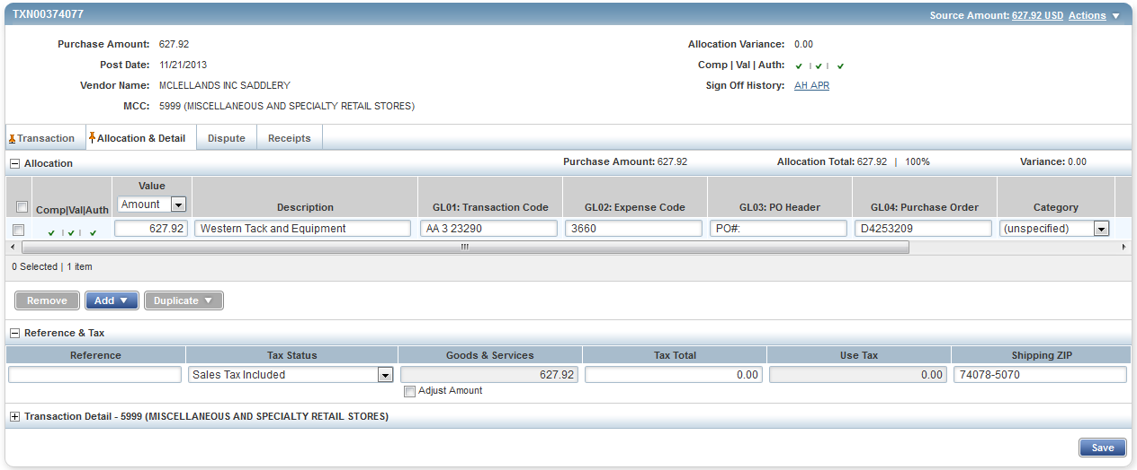
- The cardholder should have entered a description of what was purchased and the business purpose. Make sure this makes sense and is an allowable purchase.

- Make sure the account number and codes are correct. If not, highlight and make the corrections.

- To add additional lines of funding, click on the Add button and choose how many additional lines you need.
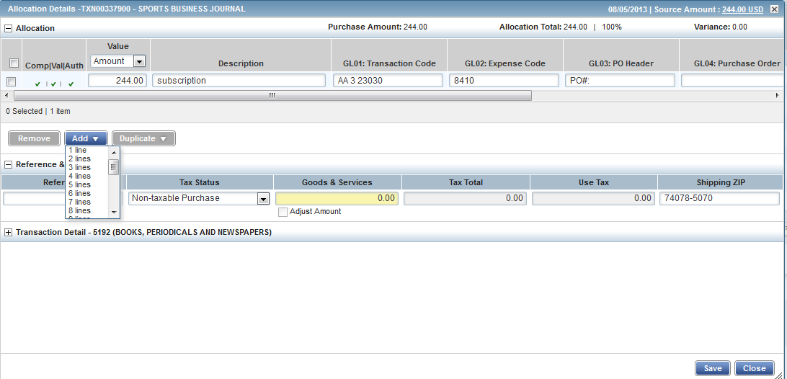
- Fill in the amount, description, account number, and subcode for the additional lines of funding.
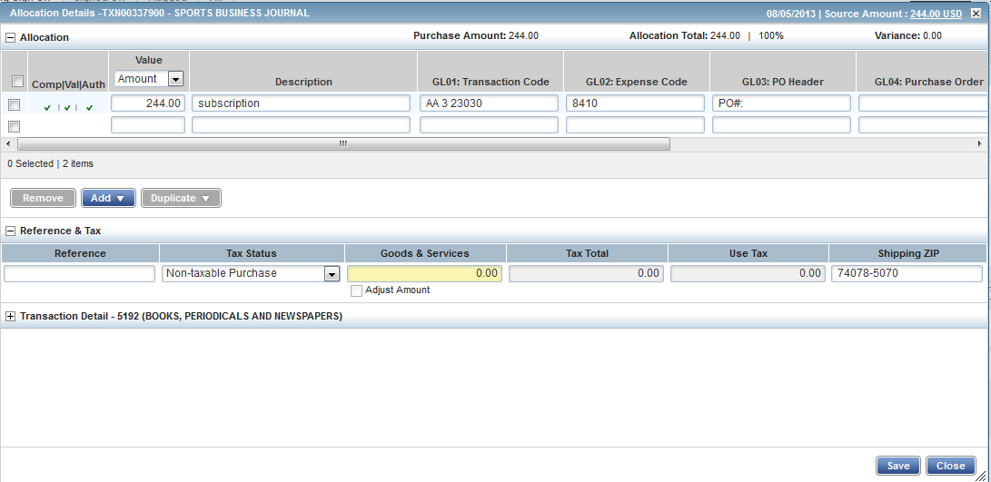

- Click Save.

- In the upper right corner of the Allocation & Detail tab, click on the Actions drop down menu.

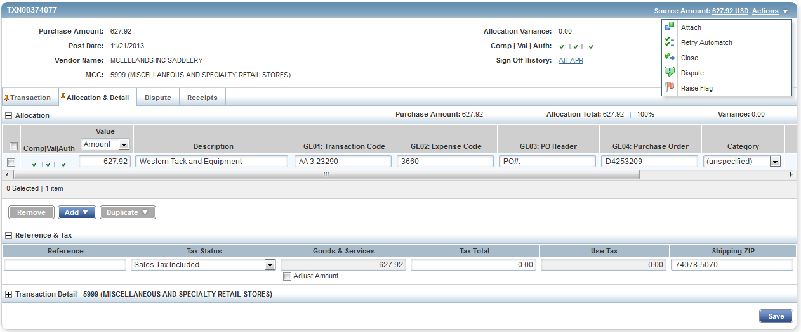

- Click Close. The Confirm Close screen displays.
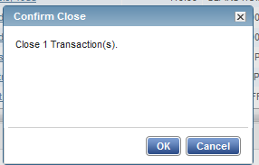

- Click OK. The closed transaction moves to the Ready to Batch screen.

- This completes the procedure.

- If you need to correct any coding after you have closed a transaction, you can find the transaction under the Ready to Batch tab until it has been downloaded and locked by University Accounting.

Sweeping a Transaction

Accountants can move transactions from their Pending Sign Off queue into their Open queue when accountholders and/or approvers have not signed off on a transaction. This allows the accountant to sign off on a transaction and verify and/or correct the accounting information when the accountholder or approver have not, or are unable to, sign off on a transaction. After the sweep occurs, neither the accountholder nor the approver may edit the transaction’s allocation codes or enter a description.

Procedure:

To sweep a transaction, complete the following:

- On the Home Page under Action Items>Sweep>Current Status, click on the Pending link.
These are the transactions awaiting accountholder and/or approver sign off.
- Select the check box for each Document you wish to sweep. The action buttons at the bottom of the screen become enabled.
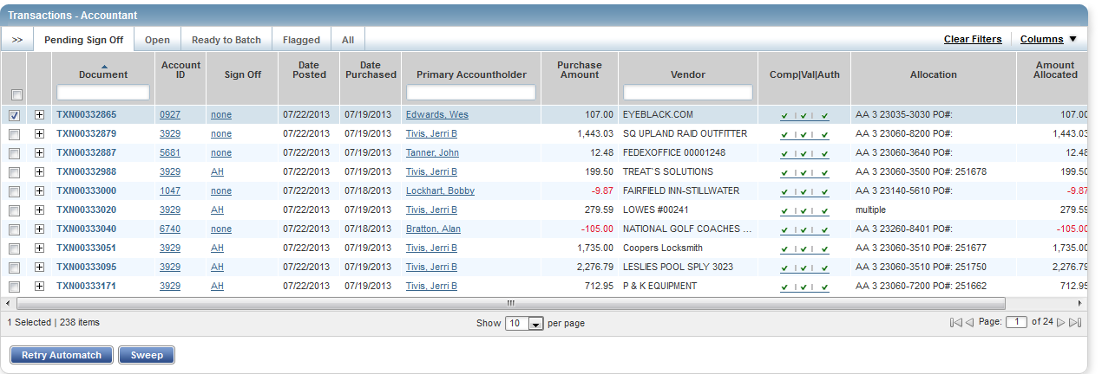

- Click Sweep. The Confirm Sweep window displays.
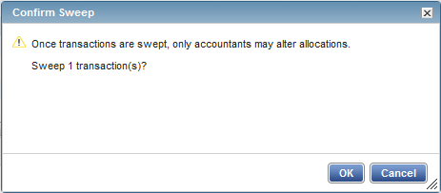

- Click OK. The transaction moves to the Open tab and is ready for accountant signoff.

- This completes the procedure.

NOTE: Even though the accountant can now sign off on the transaction, the transaction will remain on the accountholder and/or the approver screen for their sign off. The accountholder’s credit limit will not be refreshed for the amount of the transaction until both accountholder and approver have signed off on the transaction.

Managing Flags

Flags indicate transactions needing attention. Flagging the transaction sends it back to the Accountholder for a response. Once the transaction is reviewed and action taken, the flag is removed.

Notes:
- An Accountant can flag a transaction to alert other users there is an issue or question with a transaction.
- Flagging a transaction does not prevent an Accountant from closing the transaction.
- Flagging a transaction does not change its location in the workflow.
Procedure:
To manage flags, complete the following:
- On the Home Page under Action Items>Current Status, click on the Open link.
- Select the check box for the Document you wish to flag. The action buttons at the bottom of the screen become enabled.
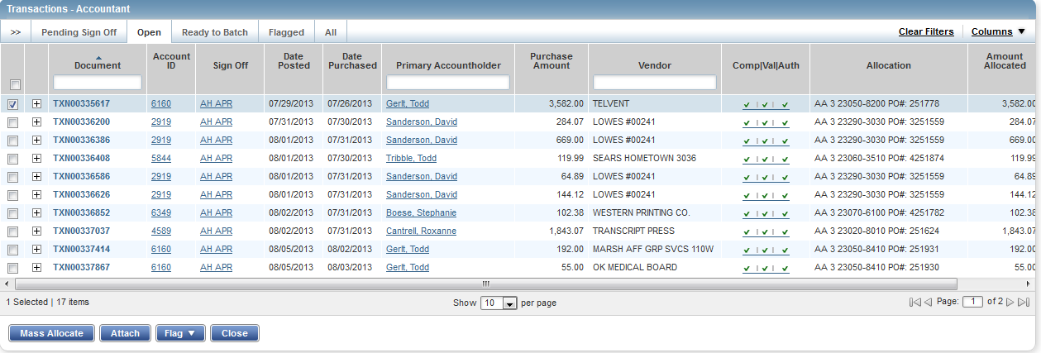
- Click Flag. A drop-down menu displays.
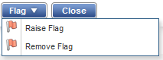
- Select Raise Flag.

- Enter a comment.
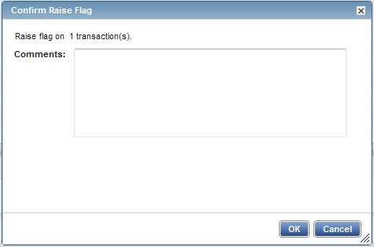
- Click OK. This sends the transaction back to the accountholder for a response.
- This completes the procedure.

Remove Flag
To remove a flag, complete the following:
- On the Home Page under Action Items>Current Status, click on the Flagged link.
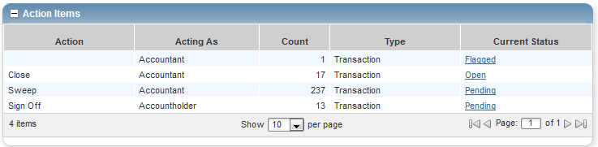

- Select the check box for the Document you wish to “un-flag.” The action buttons at the bottom of the screen become enabled.

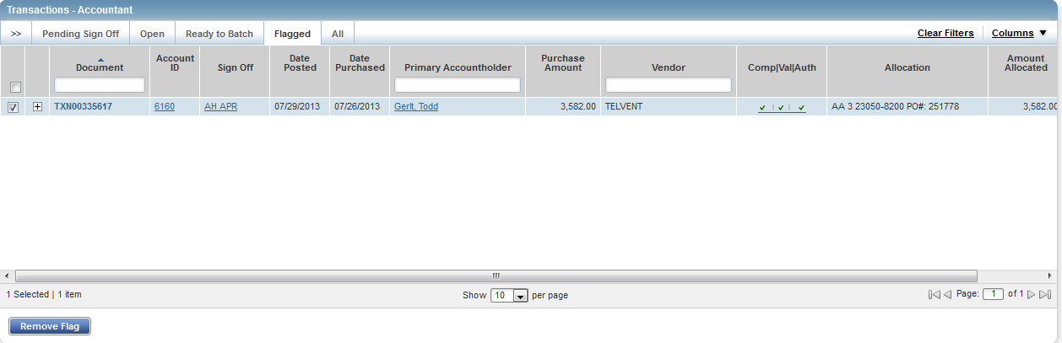

- Click Remove Flag. The window displays.

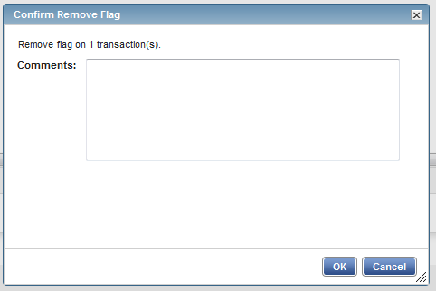

- Enter a Comment. You will not be able to remove the flag unless you enter a comment.

- Click OK.

- This completes the procedure.

