SEARCHING AND SORTING TRANSACTIONS

This guide provides information on searching and sorting transactions. Within this guide, you will learn how to:
- Search for a transaction
- Sort transactions

The Transaction Screen
NOTE: Screen shots will be from the accountant’s point of view, but the information available is the same for any user.
Procedure:
To look at your transactions, complete the following:
- On the Home Page go to Expenses>Transactions>(Accountholder, Approver or Accountant). Click on the appropriate role.
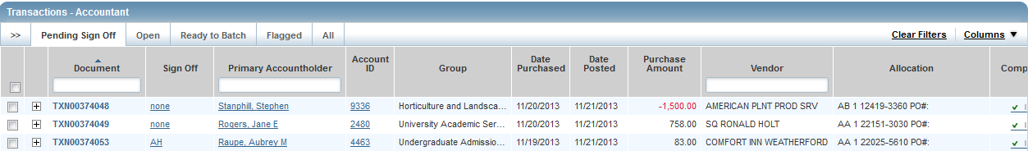
The Pending tab is the default tab that shows up.

- Pending transactions are transactions awaiting accountholder or approver sign off.

- Open transactions are transactions awaiting accountant signature. (Only accountants have access to this tab.)

- Transactions Ready to Batch are transactions that have been signed off on by the accountholder, approver, and accountant. They have not yet been locked and downloaded into SCT. (Only accountants have access to this tab.)

- Flagged transactions are transactions that have been returned to the accountholder for clarification.

- All is your transaction history. You can search for any transaction you are allowed to see as far back as the transaction remains on Works, approximately two years.

- Accountholders have access to the Signed Off tab. This tab shows all transactions the cardholder has signed off on.

To view transaction details:
- Click on the Document (TXN) number.
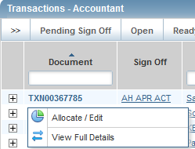

- You can choose to view the Allocate/Edit screen, or the View Full Details screen. Either screen will allow you to view the details of a transaction.
Allocate/Edit screen
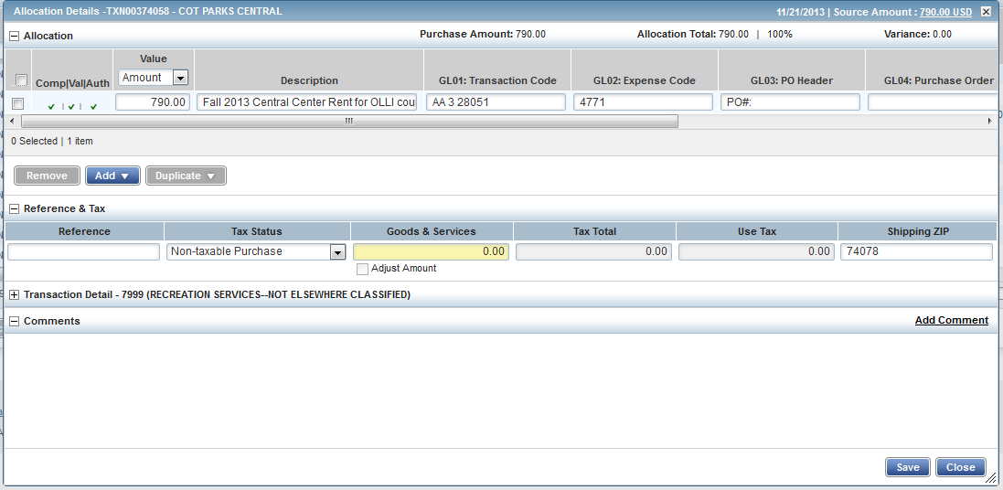
View Full Details Screen
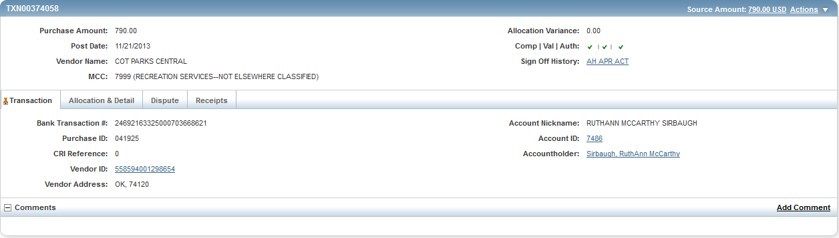
From both screens you will be able to see details of the transaction. You can click on any plus sign or tab for more details. In addition, anything in blue is a hyperlink.

To customize the columns on the transaction screen:
- Click on the Columns menu in the upper right corner of the Transaction screen.

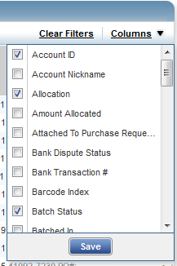

- Place a checkmark by the columns you wish to appear on your screen. Remove the checkmark from any columns you don’t need.

- Click the save button.

- You can change the order of the columns by placing your cursor in the column heading, holding the button on the mouse down and moving the column where you want it to be.

To search for a specific transaction:
- You can search using the column headers or the blank fields.

- You can search by document (TXN), accountholder or vendor by typing in the blank fields.

- By clicking in the header field you sort transactions by that field. Another click in the header field will reverse sort.

- You can also filter transactions by clicking on the double arrows in the upper left corner of the Transaction screen.

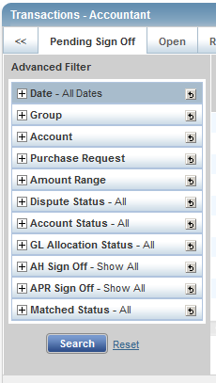

This is the Advanced Filter and can be used to search for transactions by date, group, account, etc.

- The default number of transactions that shows on the screen is 10. You can reset the number of transactions by clicking on the button in the bottom center of the transaction screen and choosing another number.
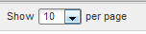
You can choose 10, 25, 50, 75, 100, 250, or 500. One of the drawbacks of Works is that you have to reset your filters every time you leave the screen and come back to it.
- Remember, anything in blue is a hyperlink.

How to look at a list of transactions:
There may be times when you want to sort and look at a list of transactions. Once you look at the details of one transaction, you can’t go back to the screen without resetting your filters. This trick will help you avoid that.
1. Pull up a list of transactions you want to review.
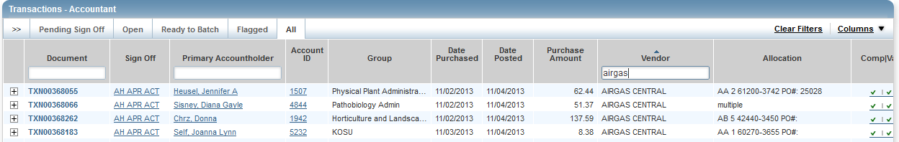
2. Left click on the Document number.
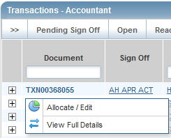
- Right click on either Allocate/Edit or View Full Details.
- This will bring up a pop up box. Choose Open Link in New Tab.

- This will open the detail for this transaction in a new tab at the top of your screen.

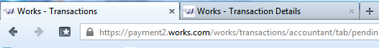

- Click on the new tab (Works-Transaction Details) and look at the details of the transaction. When you’re finished, close this tab and go back to your original list of transactions. Choose another transaction to look at the same way.

- By looking at transactions in this manner, you will not have to reset your filters every time you look at a transaction.

